Triumph Stag Rear Fog/Brake Light Upgrade

Ok, I really did not have to do this but I just like working on my car and trying to improve and add to it.

For a while now I have used the Rear Window Demist switch to power a red bulb in the offside reversing light for a rear fog lamp. The switch also has a tell-tale indicator light. It looks ok but when I saw these bulbs (below) on Classic Car LEDs website I just had to have them.

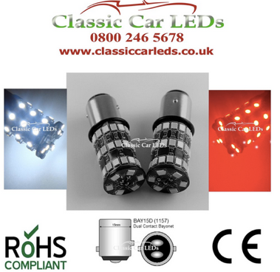

They emit a white and red LED light (BTW I have no connection with the company) and fit into the standard BAY15D bulb housing (stop/tail lamp bulb holder) I bought couple of these bulb holders from one of the Triumph parts suppliers. The LED bulbs are sold as suitable for Reversing/Brake/Fog bulbs. I decided to have all three. To do this the white is connected to the reversing light wiring, the fog is connected to the fog light switch for this I used the heated rear window switch. The brake light is connected to the brake light wiring circuit. As the bulb has only one red connection a bit of electrickery has to be done with the aid of a five pin relay. The wiring to the relay is shown below.

To LED brake/fog bulb

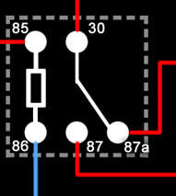
12v feed from o/s tail
12v feed from brake light
From fog light switch

Additional earthing has been fitted to the rear lamp units as I know that LEDs like good connections.

What happens in practice is, Terminal 30 is connected to the red contacts of the LED bulb
Terminal 87a is the normally closed connection and is connected to the brake light circuit which is fed from the o/s brake light wiring. This gives a circuit when there no power to the relay causing the LED to operate with the brake lights.
Terminal 87 feed from the o/s tail light, the relay only has 12v power up when the side lights of the car are on.
Terminal 85 12v feed from the fog light switch when this switched it activates the relay and cuts the power from the brake lights 87a. At this point there is no power to the LED’s so no fog lamp or brake lamp. When the side/tail lamps are switched on this feed power to the relay 87 and now the rear fog is lit.
Terminal 86 earth, the tail light housings are also connected to this earth cable.

I fixed the relay to the rear trim panel of the boot and it is hidden by the o/s tail light cover. A cable also runs behind the trim panel to the near side reversing lamp socket

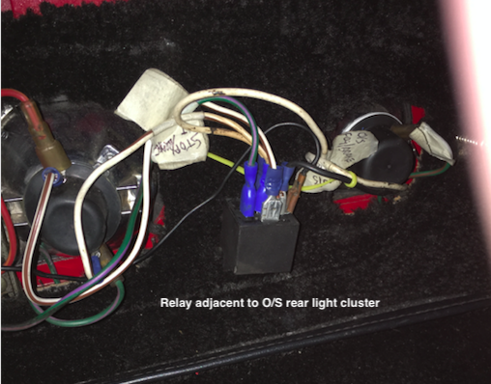

I am very pleased with my modification and also the comments that I have received from my fellow Triumph enthusiasts. During a recent run I had a few comments on how good and more visible my new brake lamps looked

The following series of photos show what the rear lights look like from the perspective of a following motorist. The rear lamps are the standard Triumph rear clusters with incandescent bulbs in the original stop/tail double filament holder. The inner lamps are the new LED’s which are fitted to new double filament holders.

If I was to be critical I would fault the reversing lights for being too white, a warm white LED would in my opinion have been better.

I am not sure how road legal my set up is but I guess the MOT man or traffic cop will let me know if they are seriously at fault. Maybe I should say that they are for show-ground use!
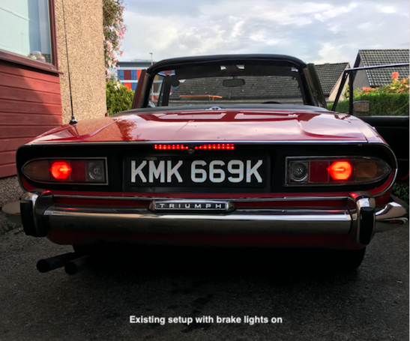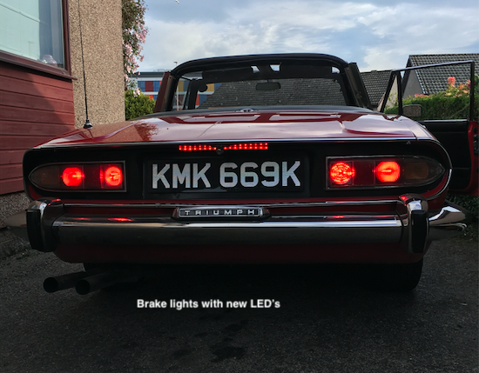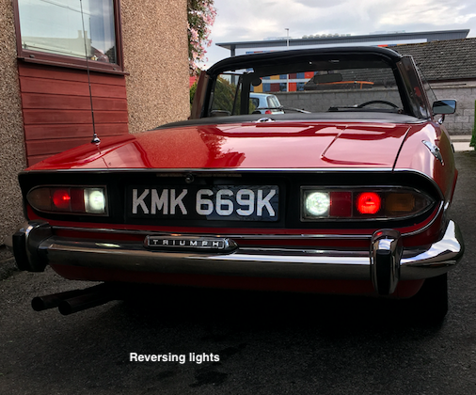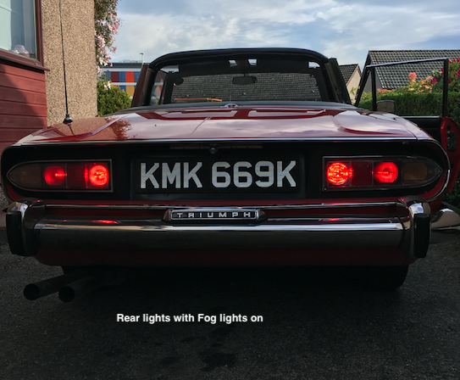

Thanks to Alan Sharpe SOC AO for the Grampian Area for hosting the website.

Danny Stroud
TSSC AO North East Scotland
SOC DAO Grampian

1972 Mk1 Stag
1967 Mk3 Spitfire
1953 Ford Anglia

